Resource Type: Email Pitch Template
Audience: Prospective flood insurance customers (without other lines of insurance with you), including dissemination through a community listserv, local partnership with realtors/lenders, or other channels you may use.
Directions: Copy and paste the template below into your preferred email platform. HTML email formatting is preferred. For a customizable, co-branded email header, visit “Marketing Resources” at Agents.FloodSmart.gov.

Subject: Don’t let your hard work be washed away – get flood insurance from [insert company]

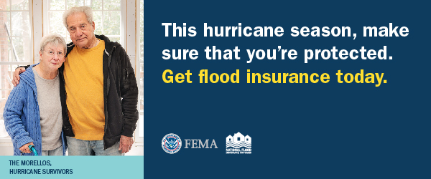
Dear [insert name of city/community] resident,
As you may know, hurricane season is officially here, and as your local [insert company name] agent, I want to make sure you are prepared. The 2018 hurricane season packed a devastating punch. 15 named storms, including Hurricanes Florence and Michael, destroyed homes and communities with costly damage.
FEMA and the National Flood Insurance Program are advising all [insert area] residents to act now [insert link to your website] to gain the peace of mind that comes with knowing your largest financial asset is protected. We strongly recommend purchasing flood insurance today because policies typically take up to 30 days to go into effect.
Flood insurance is different than homeowners insurance. Many of our clients don’t know that their homeowners insurance does not cover flood damage. Whether it’s a major flood or just an inch of water, flood insurance helps cover the cost of flood damage in the event of hurricanes like Harvey, Michael, and Florence. [link the below LEARN MORE button to your webpage.]

Here are five steps you can take today to protect the life you’ve built this hurricane season:
- Have a plan. Make a family communication plan for storms and know your evacuation routes.
- Gather emergency supplies. Create a storm bag with essential disaster supplies, like medication and key documents.
- Document all belongings. If you have flood insurance, make sure to take pictures and keep a record of your most valuable belongings. After a storm, this documentation will help you file a claim and recover more quickly.
- Prepare your home. Remove damaged trees and limbs, secure and reinforce the roof, and remove debris from gutters to prevent water damage.
- Purchase flood insurance. Most homeowners insurance doesn’t cover flood damage. With a flood policy from the NFIP, you’re covered—up to $250,000 for your home and $100,000 for belongings.

Please feel free to reach out with any questions, or to learn more about the right level of coverage for your home or business.
[insert email signature with contact information]

