Resource Type: Marketing Email
Audience: New customers (Purchase), possibly through a community listserv or local partnership with realtors/lenders
Directions: Copy and paste the template below into your preferred email platform. HTML email formatting is preferred. For a customizable, co-branded email header, visit “Marketing Resources” at Agents.FloodSmart.gov.

Subject: Protect the life you’ve built with flood insurance from [insert company]
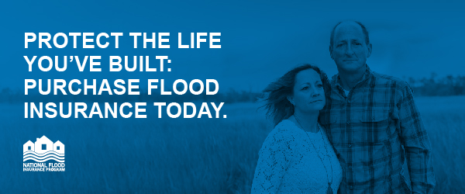
Dear [insert name of city/community] resident,
As you know, flooding can happen at any time, and as your local [insert company name] agent, I want to make sure [you are/your family is] prepared. You can’t control the weather, but you can prepare for it.
FEMA and the National Flood Insurance Program (NFIP) are encouraging all [insert area] residents to purchase flood insurance today to protect their homes and families [before [insert local flood risk, e.g. spring rains]]—policies typically take up to 30 days to go into effect.
Here are three things to know about flooding:
- Just one inch of water in an average-sized home can cause more than $25,000 in damage: In 2017, the average flood claim payment was more than $90,000.
- Flooding can happen anywhere, not just in high-risk areas: More than 25% of flood insurance claims come from outside the high-risk flood area.
- Most homeowners insurance doesn’t cover flood damage: With a flood policy from the NFIP, you’re covered—up to $250,000 for your home and $100,000 for belongings.

Please feel free to reach out with any questions, or to learn more about the right level of coverage for your home or business.
[insert email signature with contact information]

