Resource Type: Marketing Email
Audience: Existing customers (Purchase), customers who may have other lines of insurance with you, but not flood insurance.
Directions: Copy and paste the template below into your preferred email platform. HTML email formatting is preferred. For a customizable, co-branded email header, visit “Marketing Resources” at Agents.FloodSmart.gov.

Subject: Protect the life you’ve built with flood insurance from [insert company]
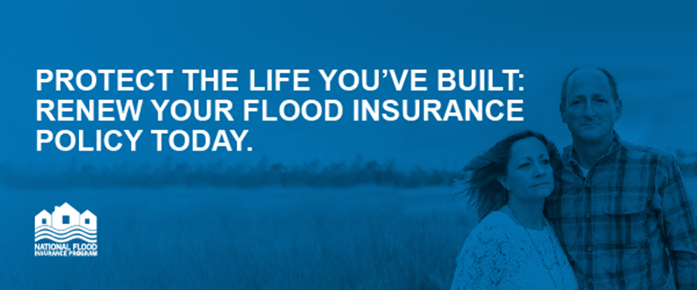
Hi [insert customer name],

[Insert client-specific greeting] As you know, flooding can happen at any time, and I wanted to check-in with [you/your family] before the next storm hits [OR insert local flood risk, e.g. spring rains]. You can’t control the weather, but you can prepare for it.

FEMA and the National Flood Insurance Program (NFIP) are encouraging all [insert area] residents to purchase flood insurance today to protect their homes and families—policies typically take up to 30 days to go into effect.

Your current [insert type of policy they currently have with you, i.e. home, renters, auto insurance policy], although important for other protections, will not protect you from flood damage. Buying flood insurance is one of most important steps you can take to protect your investment before the next storm.

Please feel free to reach out with any questions, or to learn more about the right level of coverage for your home.

[insert email signature with contact information]

P.S. Here are 3 things to remember about flooding:
- Just one inch of water in an average-sized home can cause more than $25,000 in damage: In 2017, the average flood claim payment was more than $90,000.
- Flooding can happen anywhere, not just in high-risk areas: More than 25% of flood insurance claims come from outside the high-risk flood area.
- Most homeowners insurance doesn’t cover flood damage: With a flood policy from the NFIP, you’re covered—up to $250,000 for your home and $100,000 for belongings.

