Component | Subcomponents | Status |  | Impact |  | Actions |  | Limiting Factor |  | ETA to Green
[GR] | - Police Stations  - Law Enforcement  - Site Security  - Correctional Facilities | FL |  | FL |  | FL |  | FL |  | FL
[GR] | - Fire Stations  - Firefighting Resources | FL |  | FL  AL  GA |  | FL |  | FL |  | FL
[GR] | - Local Search and Rescue | FL |  | FL |  | FL |  | FL |  | FL
[GR] | - EOCs  - Essential Govt Functions  - Govt. Offices  - Schools  - Public Records  - Historic/Cultural Resources | FL |  | FL |  | FL |  | FL |  | FL
[GR] | - Flood Control  - Other Hazards  - Protective Actions | FL |  | FL |  | FL |  | FL |  | FL

Component | Subcomponents | Status |  | Impact |  | Actions |  | Limiting Factor |  | ETA to Green
[GR] | - Commercial food distribution  - Commercial food supply chain  - Food Distribution Programs | FL |  | FL |  | FL |  | FL |  | FL
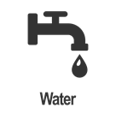  [GR] | - Drinking Water Utilities  - Wastewater systems  - Commercial Water Supply | FL |  | FL |  | FL |  | FL |  | FL
[GR] | - Housing (e.g. homes, shelters)  - Commercial Facilities (e.g. hotels) | FL |  | FL |  | FL |  | FL |  | FL
[GR] | - Animals and Agriculture | FL |  | FL |  | FL |  | FL |  | FL

Component | Key Element | Status |  | Impact |  | Actions |  | Limiting Factor |  | ETA to Green
[GR] | - Hospitals  - Dialysis  - Pharmacies  - Long Term Care  - VA Health System  - Veterinary Services  - Home Care | FL |  | FL |  | FL |  | FL |  | FL
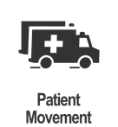 [GR] | - Emergency Medical Services | FL |  | FL |  | FL |  | FL |  | FL
[GR] | - Epidemiological Surveillance  - Laboratory  - Clinical Guidance  - Assessment/ Interventions/ Treatments  - Human Services  - Behavioral Health | FL |  | FL |  | FL |  | FL |  | FL
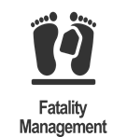 [GR] | - Mortuary and post-mortuary services | FL |  | FL |  | FL |  | FL |  | FL
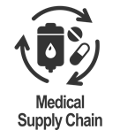  [GR] | - Blood/Blood Products  - Manufacturing  - Distribution  - Critical Clinical Research  - Sterilization  - Raw Materials | FL |  | FL |  | FL |  | FL |  | FL

Component |  | Key Element | Status |  | Impact |  | Actions |  | Limiting Factor |  | ETA to Green
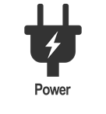 [GR] | - Generation Systems  - Transmission systems  - Distribution Systems |  | FL |  | FL |  | FL |  | FL |  | FL
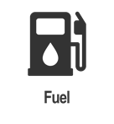  [GR] |  | - Refineries/ Fuel Processing  - Fuel Storage  - Pipelines  - Fuel Distribution (e.g. fuel points, gas stations)  - Off-shore Oil Platforms | FL |  | FL |  | FL |  | FL |  | FL

Component | Key Element | Status |  | Impacts |  | Actions |  | Limiting Factors |  | ETA to Green
[GR] | - Wireless  - Cable Systems & Wireline  - Broadcast (TV/Radio)  - Satellite  - Data Centers/ Internet | FL |  | FL |  | FL |  | FL |  | FL
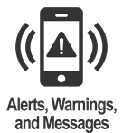  [GR] | - Local Alert/ Warning Ability  - Access to IPAWS (WEA, EAS, NWR)  - NAWAS Terminals | FL |  | FL |  | FL |  | FL |  | FL
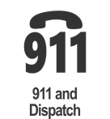  [GR] | - Public Safety Answering Points  - Dispatch | FL |  | FL |  | FL |  | FL |  | FL
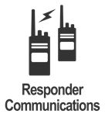 [GR] | - LMR Networks | FL |  | FL |  | FL |  | FL |  | FL
[GR] | - Banking Services  - Electronic Payment Processing | FL |  | FL |  | FL |  | FL |  | FL

Component | Key Element | Status |  | Impact |  | Actions |  | Limiting Factor |  | ETA to Green
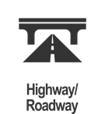  [GR] | - Roads  - Bridges | FL |  | FL |  | FL |  | FL |  | FL
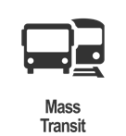  [GR] | - Bus  - Rail  - Ferry | FL |  | FL |  | FL |  | FL |  | FL
[GR] | - Freight  - Passenger | FL |  | FL |  | FL |  | FL |  | FL
[GR] | - Commercial (e.g. cargo/ passenger)  - General  - Military | FL |  | FL |  | FL |  | FL |  | FL
[GR] | - Waterways  - Ports and Port Facilities | FL |  | FL |  | FL |  | FL |  | FL

Component | Key Element | Status |  | Impact |  | Actions |  | Limiting Factor |  | ETA to Green
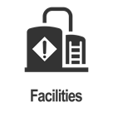 [GR] | - Oil & HAZMAT Facilities (e.g. chemical, nuclear)  - Oil/HAZMAT/ Toxic Release from Facilities | FL |  | FL |  | FL |  | FL |  | FL
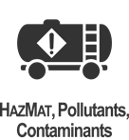 [GR] | - Oil/ HAZMAT/ Toxic Release Incidents from non-fixed facilities  - Radiological or nuclear incidents | FL |  | FL |  | FL |  | FL |  | FL

